The Story of the ‘Ghost Tree’ at Finnis/Massford

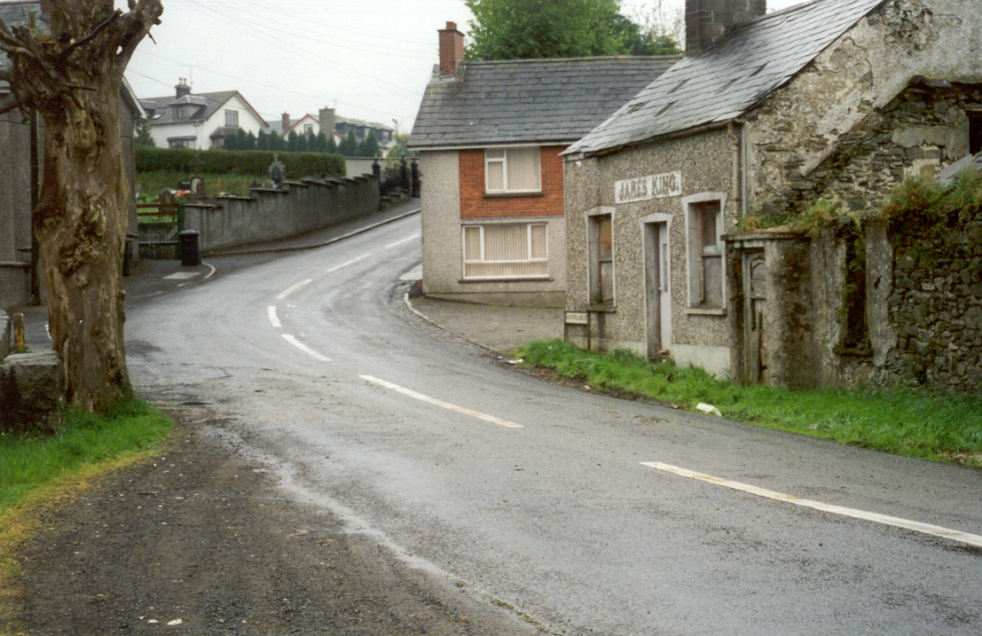

James King’s Pub in 2000

James kIng’s pub, pictured above prior to renovation in 2003, was once described as the ‘smallest, oldest and most haunted pub in Ireland’. In the photo above you can see the ‘Ghost tree’ opposite the pub which was said to house an evil spirit that was banished from the premises into a bottle which was then placed in the tree. The details of the story are unclear as is the date when this took place – it seems to date from at least the 19th century – certainly a long time ago…..

In 2003 the BBC’s ‘Your Place and Mine’ local interest radio programme came to Finnis/Massford to do a story on the opening by the Council of the nearby souterrain.

Whilst there they were here the story of the Ghost Tree was mentioned and not only did they do an excellent item on the programme and on their website on the souterrain but also featured the ghost tree story on their website. This is how they told the story…..

Finnis - a Haunted Tree?

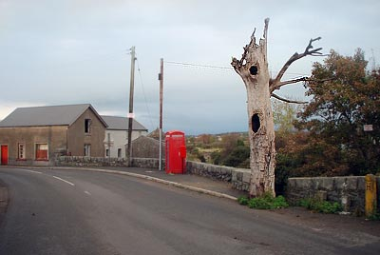
Is this distinctive tree in Finnis really haunted or has it just been struck by lightning?
“The island of Ireland must have a hundred thousand or more stories of ghosties, ghoulies and things that go bump or shriek in the night. They've been handed down through the generations and, in the re-telling, have been enhanced and embellished, sometimes out of recognition.
Yet sometimes a story sticks out because it is so local and because it is readily identifiable to a single artefact and thus goes the story of the haunted tree in the village of Finnis near Dromara in County Down.
In the early years of the 20th century a malevolent spirit is said to have haunted the area around the Dree Hill Road bridge, in the centre of Finnis, which spans the upper reaches of the River Lagan. By this bridge stood a large and beautiful sycamore tree. Knowing the terror the bridge set in the hearts of his parishioners, the village priest set out to exorcise the spirit and managed to capture it in a bottle. He then placed the bottle of spirits inside the sycamore tree.
There it remained and the bridge became free of the hauntings. From that day on and, with knowledge of the tree's part in the exorcism, nobody in Finnis would touch the tree nor would they allow anyone else to touch it either.
Subsequently the tree died and now looks as though it has been killed by a lightning strike but still it stood untouched (until July 2009 when it was felled by strong winds). Some years back, when either power lines or telephone lines were being run through the village, the tree stood in the way of progress and the priest had to be called to stop the workers from cutting it down. As a result they had to run the cables through the tree's upper branches. “
When the tree was felled by strong winds in July 2009 the Dromore Leader reported that a collective shudder passed through the local community….
Published on Friday 17 July 2009
FINNIS'S famous haunted tree has finally been felled and the whereabouts of the evil spirit it was claimed it imprisoned is now unknown.
Villagers, generations of whom are said to have stood watch over the tree and its captive spirit, were shocked to find the lightning-blasted sycamore shell had gone, victim of another, recent, storm.
It was almost a year ago to the day, on July 22 last year, that The Leader published the ghostly tale of the tree and the malicious spirit said to be literally bottled up within it.
The local legend has such power that one relative newcomer, set to move away from the area in coming weeks, said she was glad to be leaving now that the tree had been lost.
The story goes that in the early 20th century a malevolent spirit haunted the Dree Hill Road bridge in the centre of Finnis; the village priest exorcised the spirit, capturing it in a bottle, which he placed inside a nearby sycamore tree, so ending the hauntings.
The reader who contacted The Leader with the tale last year said at the time that from that day on nobody in Finnis would touch the tree or allow anyone else to touch it.
"Some years back," he said, "when either power lines or telephone lines were being run through the village, the tree stood in the way of progress and the priest had to be called to stop the workers from cutting it down; as a result they had to run the cables through the tree's upper branches."
Even after the dawn of the 21st century, many decades after the alleged exorcism, he said, any mention of removing what remained of the long-dead tree still stirred strong emotions among some locals.
According to another resident, last August's floods broke off a part of the tree, which lay where it fell for a long time before anyone would touch it.
But now nature has succeeded where even the march of progress failed and for one woman, sad at the thought of her upcoming move from an area she arrived in just two years ago, the tree's loss has shed new light on her leaving.
"I was driving over the bridge on my way home from work," she said, "and I couldn't believe my eyes; the tree was gone, just a wee stump of it left; I was told it had come down in the weekend storms.
"I've only lived here a couple of years and I was shocked so I can't imagine what some of the older residents make of it.
"I'm moving at the end of the month and now I'm glad I'm going to tell the truth."
On a lighter note – (if its not tempting fate to say so) no harm seems to have come from the loss of the tree – except the loss of a local landmark. One local remarked that so many bottles had been thrown into the hollow of the dead tree over the years that it would be impossible to identify one with the unwelcome added addition of a genie!

Links to BBC Your Place and Mine web site re Finnis Haunted Tree and Binder’s Cove/Finnis Souterrain.
http://www.bbc.co.uk/northernireland/yourplaceandmine/down/A1934651.shtml
http://www.bbc.co.uk/northernireland/yourplaceandmine/down/A1956017.shtml

